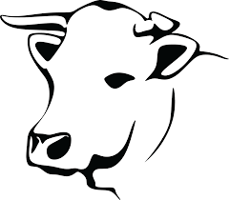
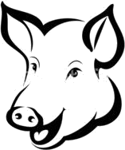

LITTLE FOLK’S MENU

MINI FISH & FRIES
~
DERBYSHIRE BEEF SLIDER & FRIES
~
CHICKEN GOUJONS & FRIES
~
SAUSAGE & MASH

(ADD PEAS, BEANS OR SALAD TO ALL OF THE ABOVE)

CHEESY PASTA
All £7.95
~ ~ ~
TRADITIONAL SUNDAY ROAST BEEF OR CHICKEN
(SUNDAYS ONLY)
£9.95
~ ~ ~
2 SCOOPS OF ICE CREAM (ASK FOR FLAVOURS)
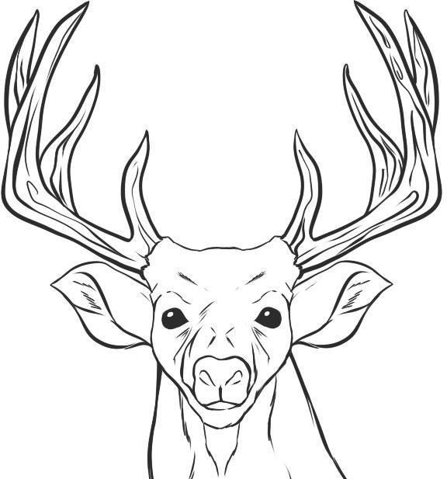
~ ~ ~
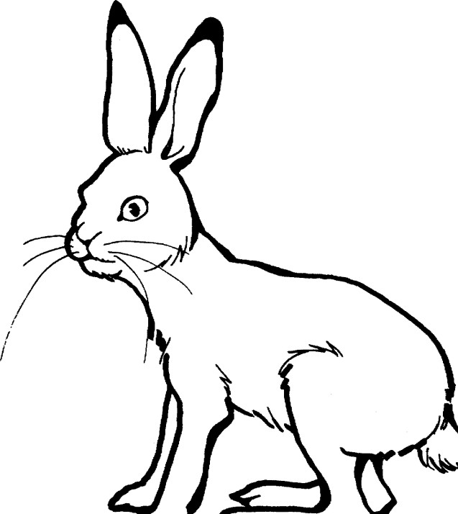
WARM CHOCOLATE BROWNIE & VANILLA ICE CREAM
~ ~ ~
STICKY TOFFEE PUDDING
£4.95

